
Test Two
Teacher:

Mr Staffe

Mrs. Carter

_____Mr Bertram

_____Mr Roohi

_____Ms Cheng

Semester One 2016
Year 12 Mathematics Methods
Calculator Free
Name:

- Complete all questions
- Show all necessary working
- Total Marks = 20
- 20 minutes

1. [9 marks]

Find 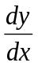 in each of the following, by using the appropriate rule. DO NOT SIMPLIFY.
(a) 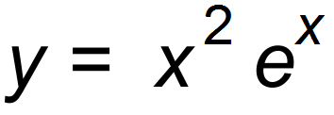 [2]

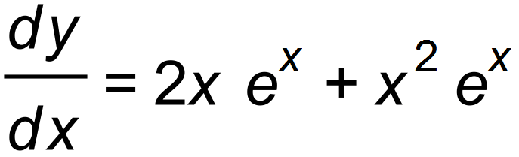

(b) 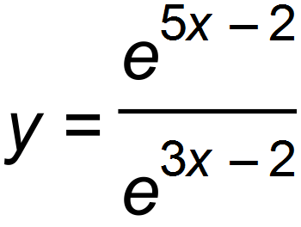 = e ^{2x} [2]

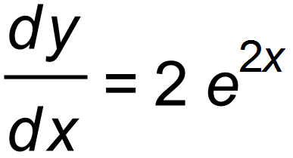

(c) 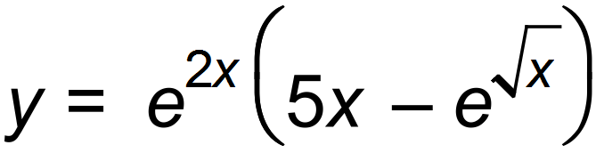 [3]

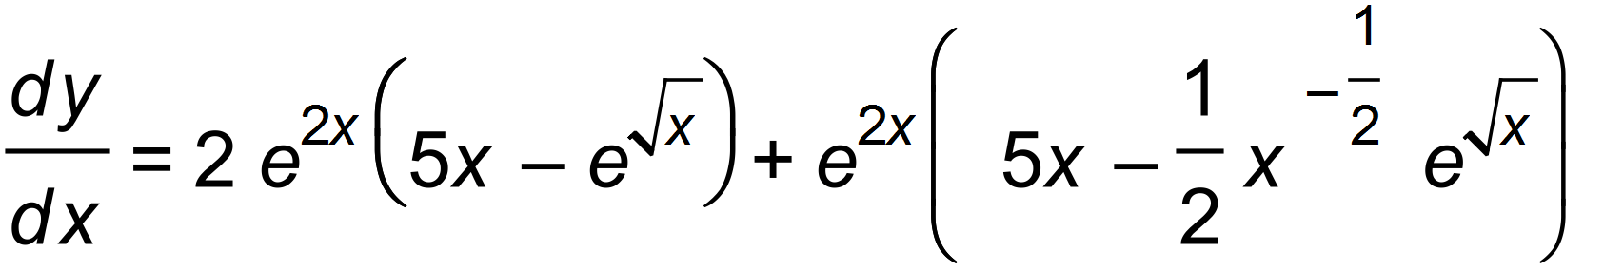

(d) Simplify 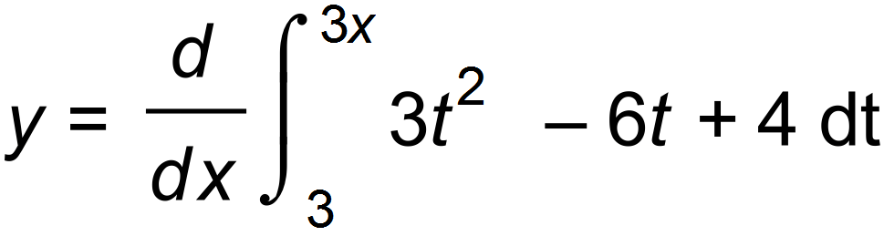 [2]

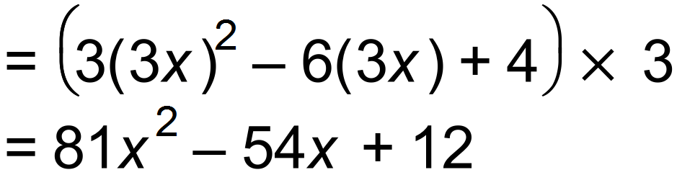

2. [11 marks]
Simplify the following integrals
(a) 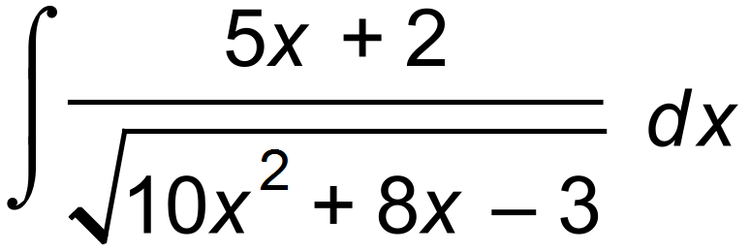 [3]
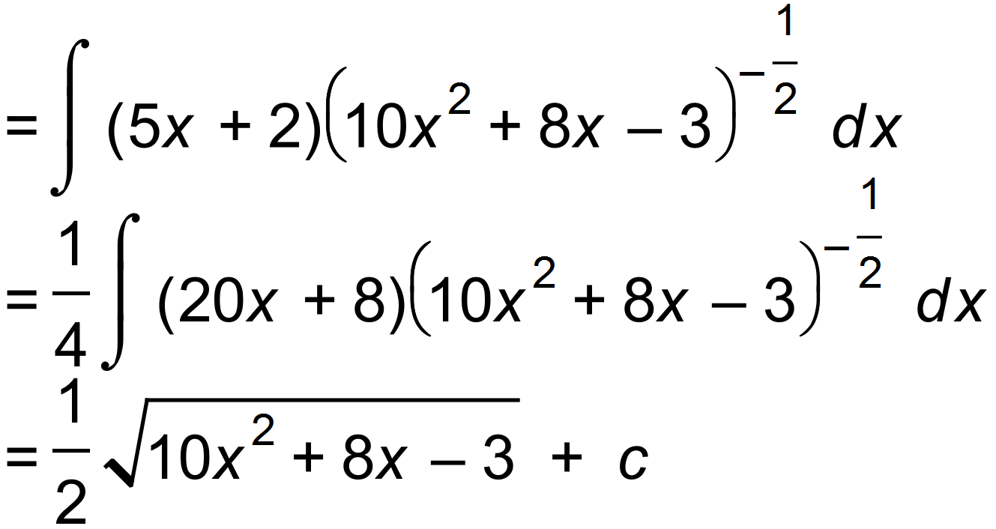
(b) 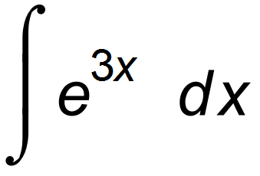 [2]
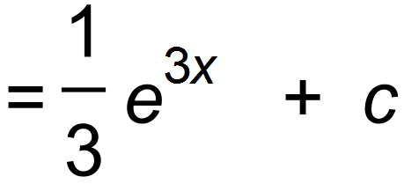

(c) 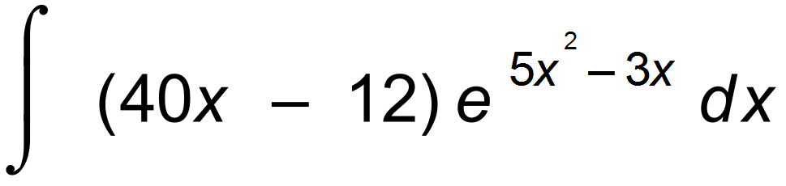 [3]
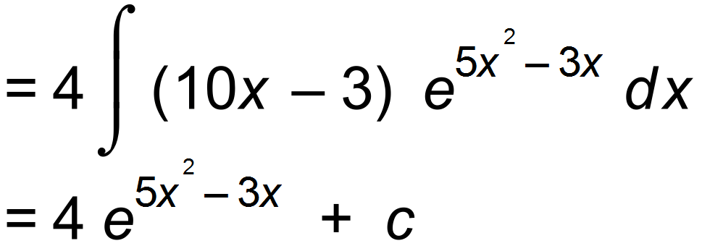

(d) Evaluate 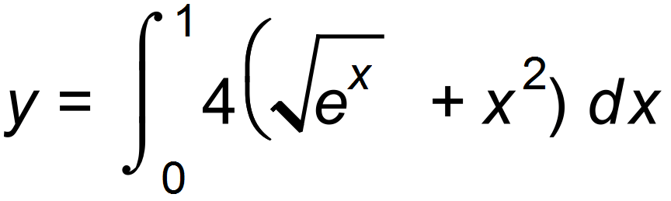 Leave as exact value [3]
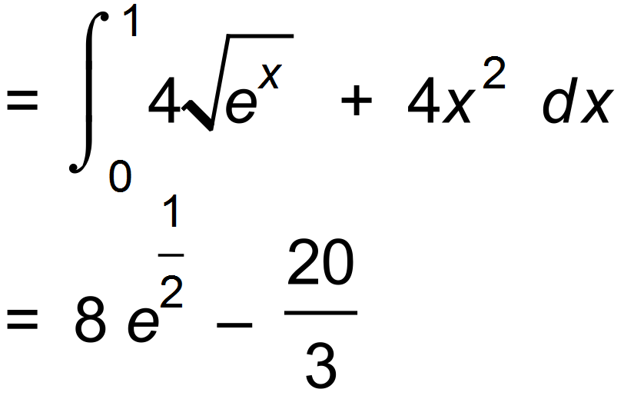

Teacher:

Mr Staffe

Mrs. Carter

_____Mr Bertram

_____Mr Roohi

_____Ms Cheng

Test Two

Semester One 2016
Year 12 Mathematics Methods
Calculator Assumed
Name:

- Complete all questions
- Show all necessary working
- Total Marks = 30
- 30 minutes

1. [ 8 marks ]

- Find the area enclosed by the curve y = x² – 3x – 4 between the values x = 2 and x = 5, and the x – axis.

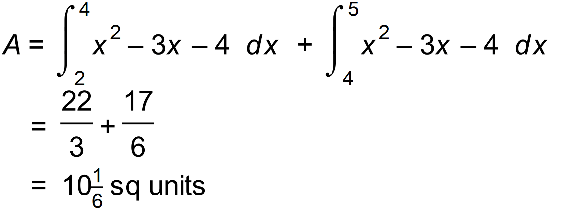

- Find the area between the curves curve f(x) = (x + 1)(x – 1)(x – 2) and g(x) = 4x² - 28

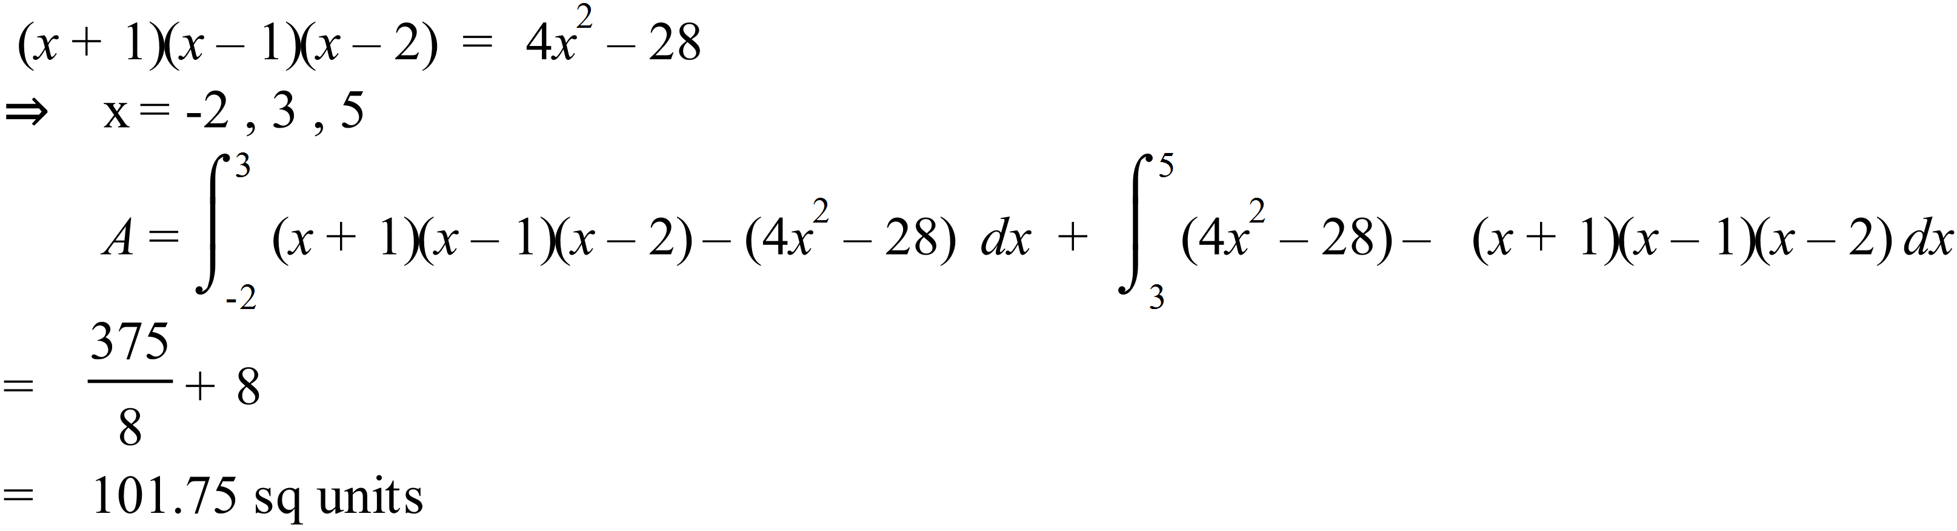

2. [ 6 marks ]
A sweeping “circular” driveway actually has two parabolas as its edges to allow parking near the house. The x – axis is the edge of the roadway and the driveway lies between the curves
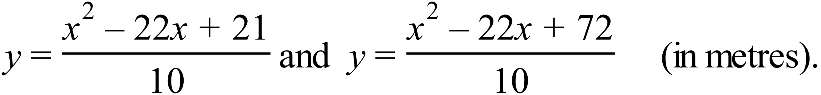

- Draw a sketch showing the situation . Does not have to be to scale. [1]

- Find the area of the driveway and hence the cost of concreting to a depth of 15cm, with concreting costing $350 / m³ . [5]

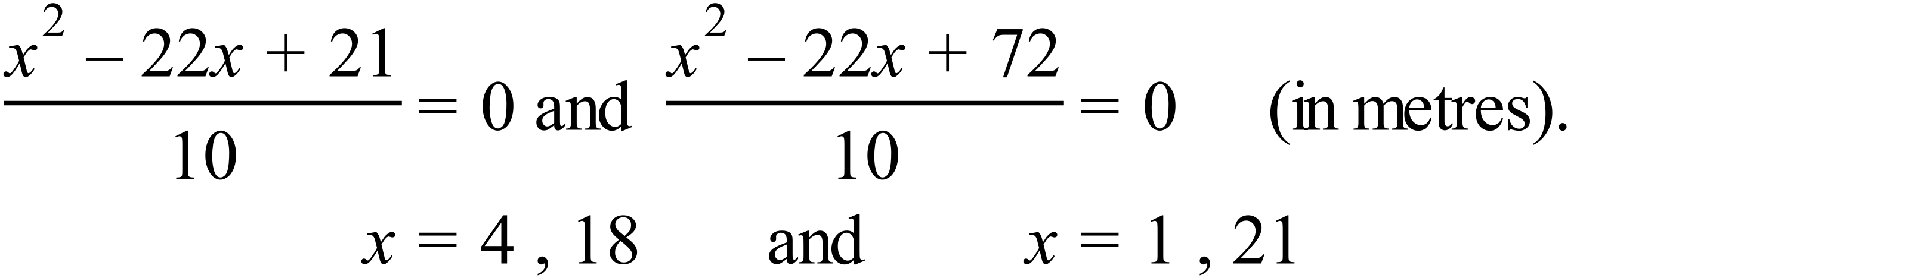

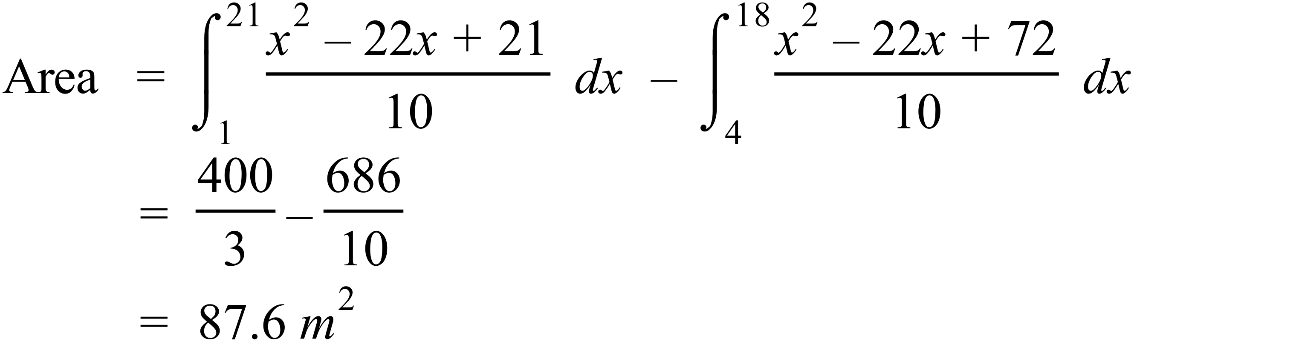

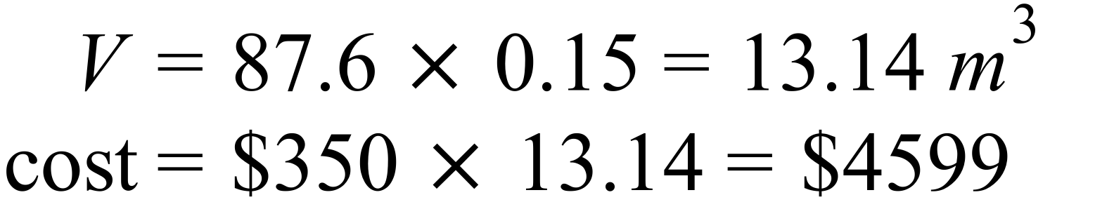

3. [6 marks]

Following the Second World War, there was a significant increase in the birth rates among the western countries. If it is assumed that the rate of births in millions of babies per year for the post war years is approximated by B’(t) = 2t + 5 for 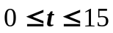 , find

- How many babies were born in the first 15 years after the war? [3]

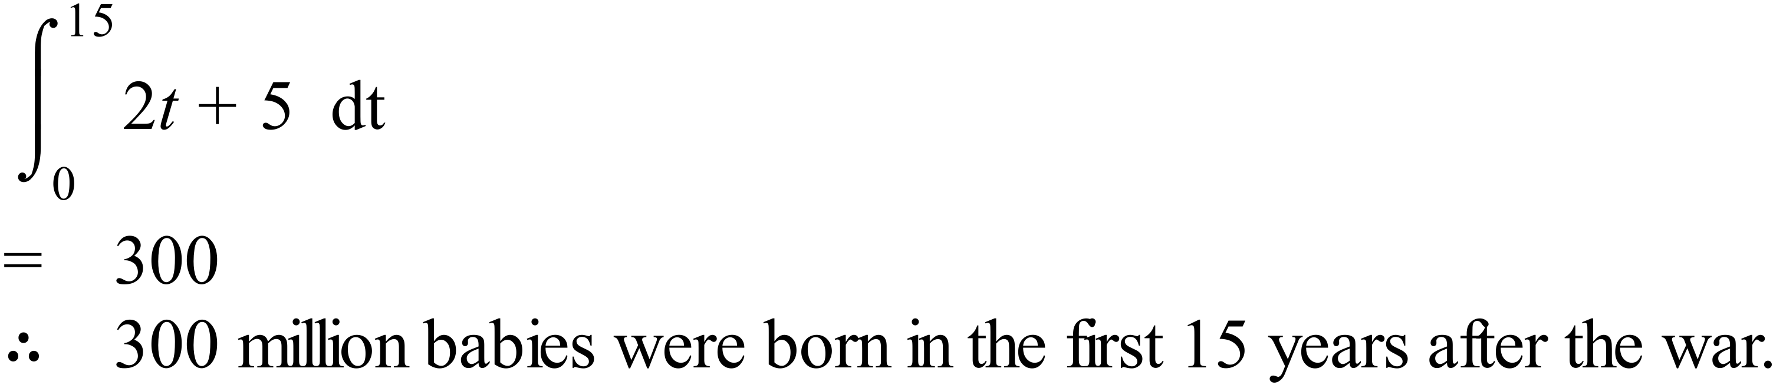

- How long did it take for the number of babies born after the war to reach 104 million?
[3]
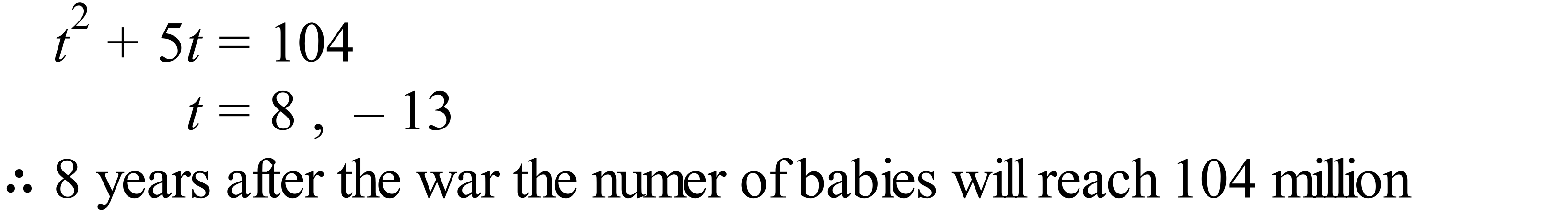

4. [4 marks]
The velocity of a particle moving in a straight line is given by 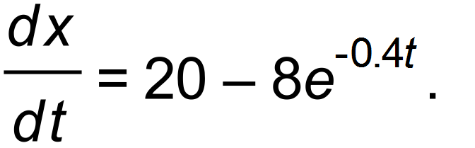 Calculate the total distance travelled by the particle in the first 3 seconds.
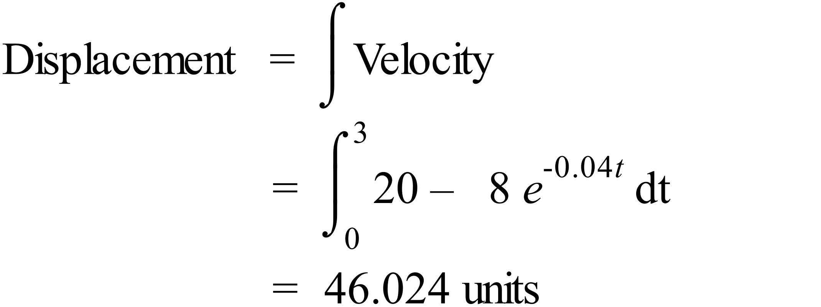
The Particle travels 46.024 units in the first 3 seconds.

5. [6 marks]
A Colour dye with initial concentration of 0.7 units is placed into a tub of water, and the rate of change of the dye is given by 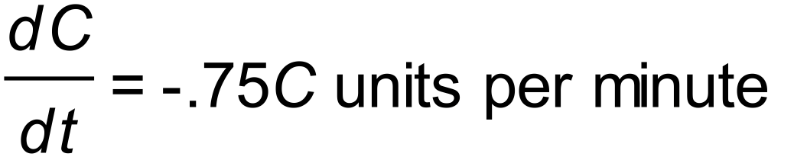 where C = C(t) is the concentration of the dye at any time t minutes after being placed into the tub.
- Find C as a function of t. [1]
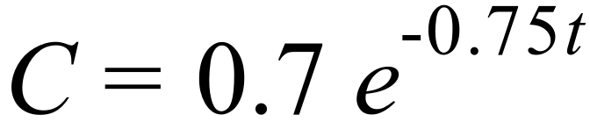

- Calculate the concentration of dye 2 minutes after the dye was placed into the water.
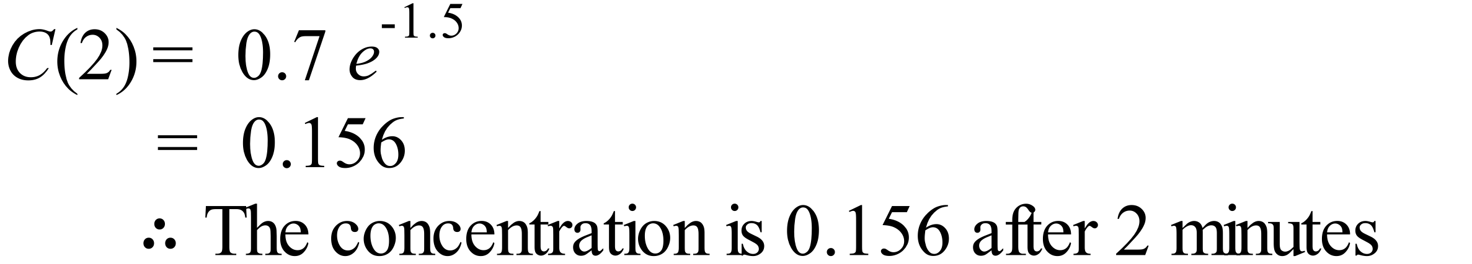 [2]

- How long does it take for the concentration of dye to be 0.1 units ? [3]

